Plan van Aanpak
AI Cassette Inspection Platform
Dynamic Multi-Robot, Multi-Camera Vision System
UV Series + 2000 Series | 6-inch + 8-inch | 25-Slot Cassettes
Computer Vision for Real-Time Quality Control

Trymax Semiconductor Equipment B.V.
Bijsterhuizen 11-52, 6534 AS Nijmegen
Internship: February 9, 2025 - July 3, 2025 (20 weeks)
Student: | Anton Horvat
Company Supervisor: | [Name]
School Supervisor: | [Name]
Version: | 7.0
Date: | February 2026

1. Introduction 1
1.1 Background 1
1.2 Problem Statement 1
1.3 Objective 1
1.4 SlotOccupationState Enum 1
1.5 Robot Raw Format (2000 Series) 1
1.6 Research Questions 1
2. Project Scope and Delivery Levels 1
2.1 Overview 1
2.2 Level 1: Frontend Web Application 1
2.3 Level 2: Callable API + Frontend 1
2.4 Level 3: Full Production System 1
2.5 Decision 1
3. The Application 1
3.1 Camera Operating Modes 1
3.2 Full-Stack Architecture 1
3.3 Self-Improving AI Loop 1
3.4 Dynamic Robot and Cassette Support 1
3.5 Functional Requirements 1
3.6 Technical Requirements 1
3.7 Build Order: What Comes First? 1
4. Technical Approach 1
4.1 AI Model Pipeline 1
4.2 Data Strategy 1
4.3 Explainable AI (XAI) Strategy 1
4.4 Technology Stack 1
5. Planning (20 Weeks) 1
5.1 Phase Overview 1
5.2 Detailed Weekly Breakdown 1
6. Success Criteria 1
7. Risks and Mitigation 1
8. Communication and Supervision 1
9. Deliverables 1
10. Glossary 1

(Right-click > Update Field in Word to refresh)

1. Introduction

1.1 Background
Trymax Semiconductor Equipment B.V. manufactures plasma-based NEO series machines for the semiconductor industry. These machines are used worldwide for plasma etching and deposition. With over 500 installed process chambers and a target of 1,000 by the end of 2025, operational efficiency is a key differentiator for Trymax.
Within the current production workflow, each wafer cassette (a 25-slot tray that holds either 6-inch or 8-inch wafers) is inspected by a mechanical mapper mounted on the robot arm. This mapper checks each slot one by one, and the whole process takes about 30 to 45 seconds per cassette.

1.2 Problem Statement
The mechanical mapping process is a throughput bottleneck. At 30 to 45 seconds per cassette across hundreds of daily operations, the cumulative time loss is significant. On top of that, the mapper provides no visual evidence of its findings, which makes it difficult for engineers to verify what actually happened during an inspection.

1.3 Objective
My task is to develop an AI-powered computer vision proof-of-concept that can inspect 25-slot wafer cassettes using a camera image in under 1 second (a 30 to 45x speed improvement). The system should classify each slot using the industry-standard SlotOccupationState enum, provide Explainable AI visualizations (Grad-CAM) so engineers can see why the AI made each prediction, and run side-by-side with the current mapper for trust validation. The end result is a web application with a callable API, depending on the chosen delivery level.

1.4 SlotOccupationState Enum
The SlotOccupationState enum is the industry standard for describing what is in each slot of a wafer cassette. Every prediction my AI model makes will use these values:
Value | State | Description
0 | Undefined | Cannot determine slot state
1 | Empty | No wafer present in slot
2 | NotEmpty | Something detected but unclear
3 | CorrectlyOccupied | Wafer properly placed in slot
4 | DoubleSlotted | Two wafers stacked in one slot
5 | CrossSlotted | Wafer extending across slots
6 | Reserved | Reserved for future use

1.5 Robot Raw Format (2000 Series)
The 2000 series machines use a different numbering system at the hardware level. When I started looking into this, I learned that the robot mapper sends raw values that the Trymax software then translates into the standard SlotOccupationState enum. This translation happens before the data reaches my AI system, so the AI model only works with the software-level format. But I still need to understand the translation, because the mapper logs from 2000 series machines use the raw robot values as ground truth.
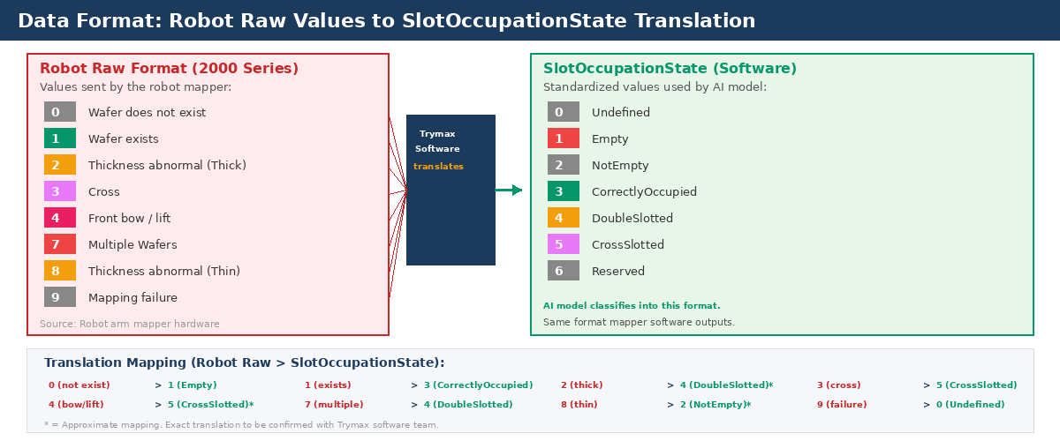
Figure: Robot Raw Format Translation (2000 Series)
The approximate mappings still need to be confirmed with the Trymax software team. For the AI model this does not matter directly, because I classify into SlotOccupationState values. But when I compare my AI predictions against the mapper ground truth from 2000 series logs, I need to know the translation is correct.

1.6 Research Questions
The main research question driving this project is: How can a computer vision system reliably classify 25-slot wafer cassette states from camera images in under 1 second, while providing explainable predictions that engineers can validate against the existing mapper?
To answer this, I broke it down into five sub-questions: (1) What visual features distinguish Empty, CorrectlyOccupied, DoubleSlotted, and CrossSlotted states? (2) Which CNN architecture provides the best accuracy-to-speed tradeoff? (3) How can the model remain robust against varying backgrounds and lighting? (4) How effective is Grad-CAM at explaining predictions to semiconductor engineers? (5) What system architecture best serves both engineers (visual dashboard) and software (API)?

2. Project Scope and Delivery Levels

2.1 Overview
This project can be delivered at three levels of increasing scope. Each level includes everything from the level below. I designed it this way because I wanted to be honest about what I can realistically achieve in 20 weeks. My internship coordinator is aware that this is my first time working with AI, computer vision, and building a full application from scratch, and we agreed that I should push as far as I can while making sure the foundations are solid.
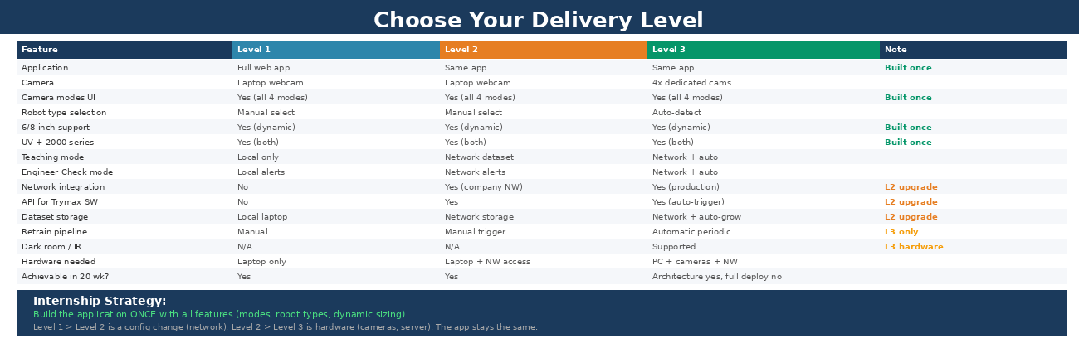
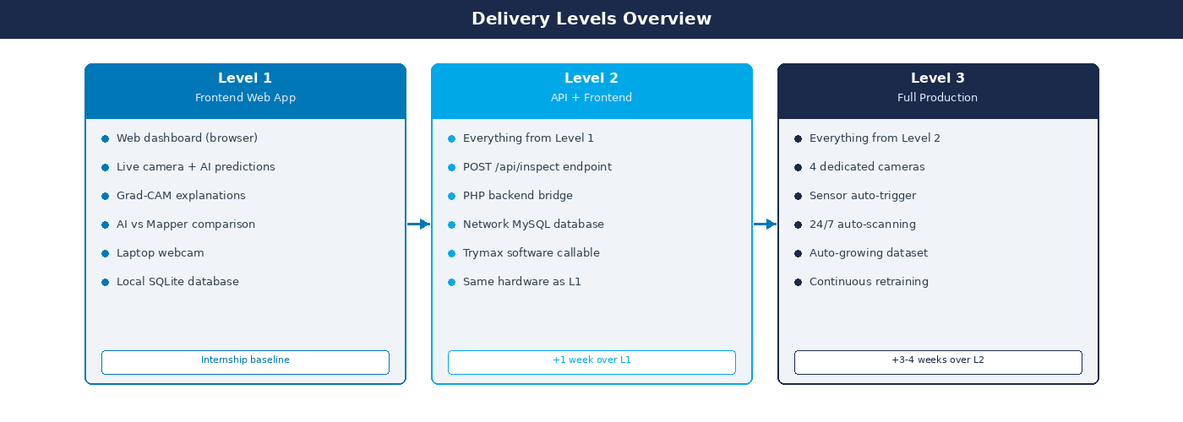
Figure 1: Delivery Levels Comparison

2.2 Level 1: Frontend Web Application
Level 1 is the core deliverable. It is a web-based dashboard that runs in any browser on the Trymax network. The dashboard shows a live camera feed with the AI prediction overlay, a side-by-side comparison table where you can see the AI result and the mapper result for every single slot, Grad-CAM explanations for flagged anomalies, and an inspection summary with counts and timing.
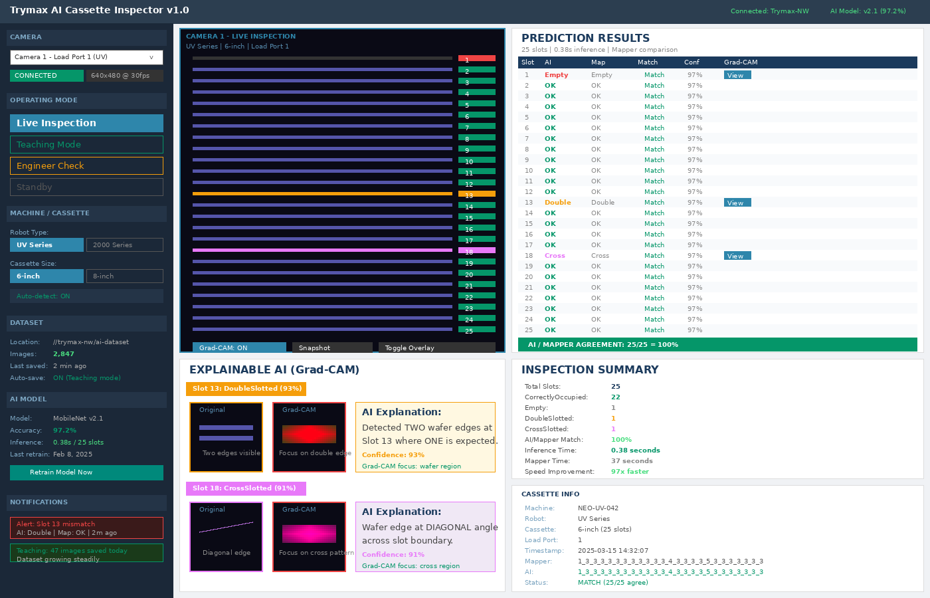
Figure 2: Level 1 End Result - What Engineers See
The idea behind the dashboard is trust through transparency. Engineers do not have to take the AI's word for it. They can see both results for every slot, with a Match column proving agreement. Every prediction also has a Grad-CAM heatmap showing where the model looked and why it classified each slot the way it did.
For the camera, I am using my laptop webcam as a prototype. This is not production quality, and I know that. But the camera input is abstracted in the architecture, so replacing it with any IP camera later is just a configuration change. Level 1 has no connection to the Trymax NEO software. It is a standalone dashboard that proves the concept works.

2.3 Level 2: Callable API + Frontend
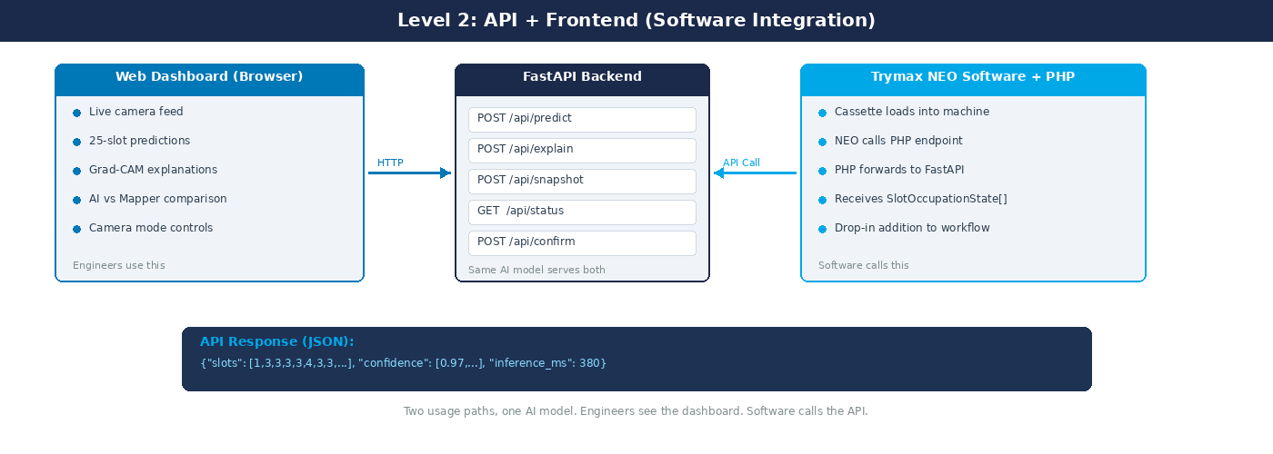
Figure 3: Level 2 End Result - Software Integration Added
Level 2 adds a clean API endpoint (POST /api/inspect) that Trymax's NEO software can call. The software sends an image and receives the SlotOccupationState array as JSON. A PHP backend handles the communication between the NEO software and my FastAPI service, acting as a bridge so I do not need to modify the existing Trymax software.
There are now two usage paths, but they share the same AI model. Engineers still use the browser dashboard. The Trymax software calls the API programmatically. After the internship, Level 2 is essentially integration-ready: changing the camera URL in the configuration is the only step needed for production cameras.

2.4 Level 3: Full Production System
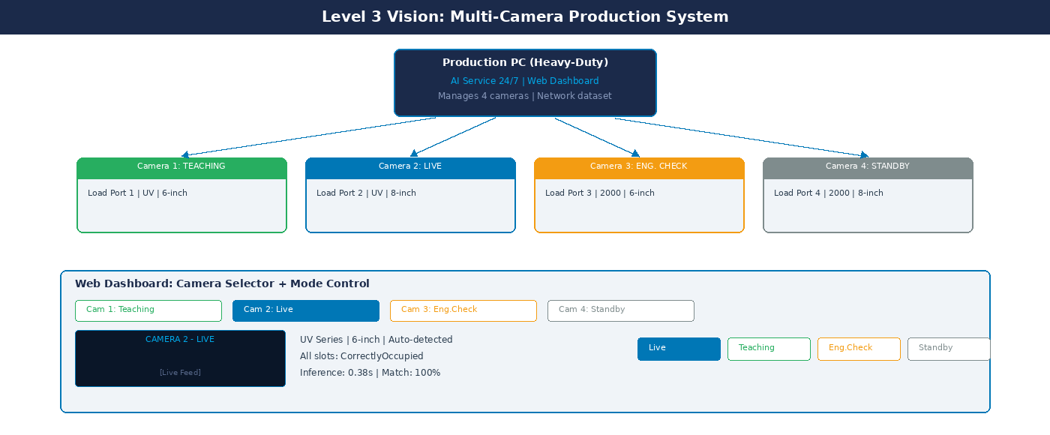
Figure 4: Level 3 Vision - Multi-Camera Production Dashboard
Level 3 is the full production vision. The same application runs on a production PC with 4 dedicated cameras, one at each load port. Every cassette load auto-triggers AI inspection via sensors. Results get sent to the Trymax software automatically, and every scan is saved to a growing dataset for continuous model improvement.
The dashboard gains four production-specific panels: production status (scans today, uptime, alert count), an auto-growing dataset counter, a continuous learning indicator (model version, accuracy trend over time), and an alert system for AI/mapper disagreements.
Level 3 requires extra hardware: camera purchases, a production server, and sensor integration for auto-triggering. This is about 3 to 4 extra weeks of work over Level 2 and may extend beyond the 20-week internship depending on hardware delivery.

2.5 Decision
Level 3 is where I want to end up, but I have to be realistic. This is my first time working with AI, computer vision, and building a full application from scratch. My internship coordinator is fully aware that I probably will not finish everything in 20 weeks, and that is completely fine. The idea is that I push as far as I can, ideally delivering a working Level 2 system (the full app connected to the company network), and that I document the Level 3 architecture so clearly that whoever continues after me can pick it up without starting over.
The most important thing is that the application works and that the architecture is solid. If I get to Level 2 with a well-designed system that is ready for Level 3 hardware, that is a successful internship. If I get further than that, even better.
Please indicate the target delivery level: Level 1 / Level 2 / Level 3

3. The Application
The project delivers a single application that serves as the complete AI inspection tool. I am building this application once, and it is the same across all delivery levels. What changes per level is the hardware it runs on and whether it connects to the network. This was a deliberate design decision: one solid application that scales is better than three fragile prototypes.

3.1 Camera Operating Modes
I designed four operating modes because different situations need different behaviors from the camera:
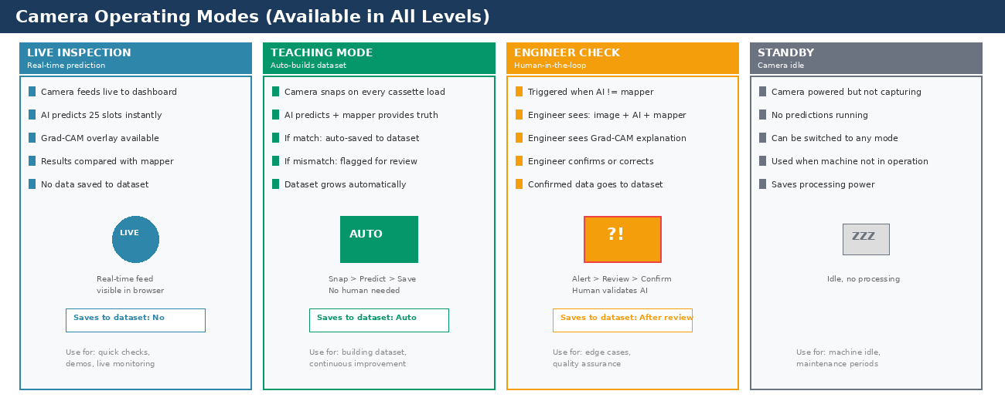
Figure 5: Four Camera Operating Modes
Live Inspection: This is the default mode. The camera gives real-time predictions compared with the mapper, but nothing gets saved to the dataset. I use this for quick checks, demos, and monitoring.
Teaching Mode: This is the clever part. When the mechanical mapper finishes its inspection, it fires an event in the Trymax software. My application listens for that event and automatically takes a camera snapshot at that exact moment. The AI then predicts the 25 slots and compares with what the mapper found. If they match, the image gets saved to the dataset automatically, no human needed. If they disagree, the image gets flagged for an engineer. This way the dataset builds itself over time.
Engineer Check Mode: Triggered when AI and mapper disagree. The engineer sees the image, both predictions, and the Grad-CAM explanation. They confirm or correct, and the data goes to the dataset.
Standby: Camera powered but not capturing. No processing. Used during maintenance or when the machine is idle.

3.2 Full-Stack Architecture
Before I explain how the self-improving loop works, it helps to understand how all the pieces of this project fit together. There are a few different technologies involved and they each have a specific job:
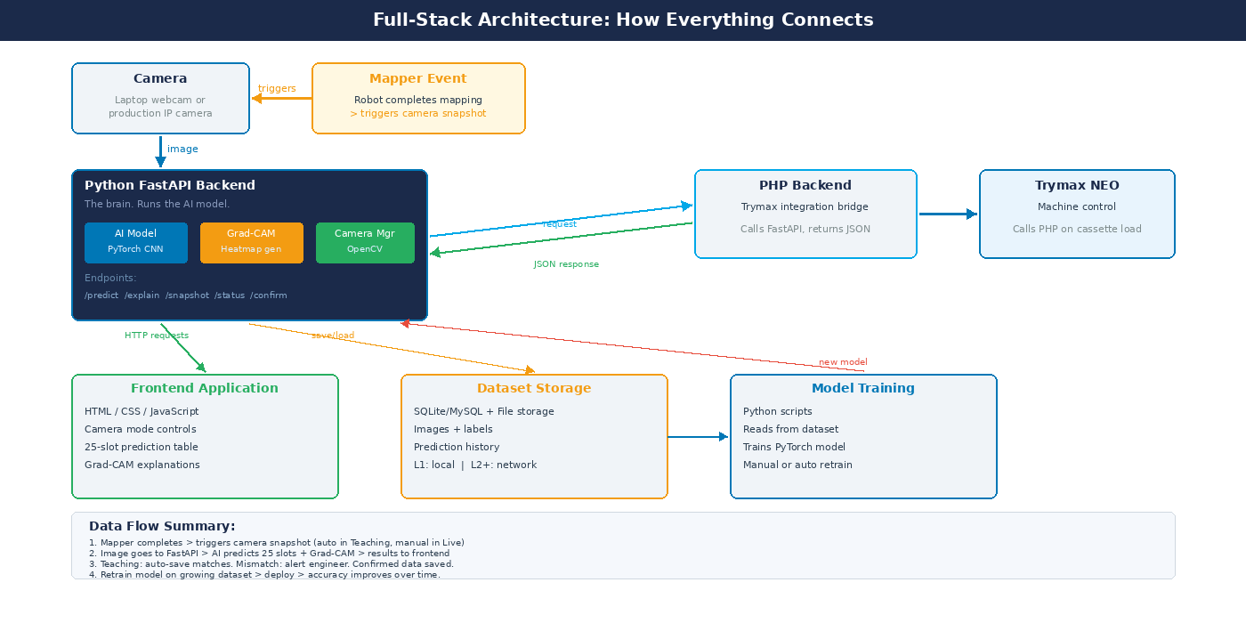
Figure 6: Full-Stack Architecture - How Everything Connects
Python FastAPI (the backend): This is the brain of the system. It runs the AI model (PyTorch CNN), generates Grad-CAM heatmaps (OpenCV), and manages the camera feed. It exposes API endpoints like POST /api/predict and POST /api/explain. I chose FastAPI because it is fast, lightweight, and works perfectly with Python ML libraries.
HTML/CSS/JavaScript (the frontend): This is what the user sees. It shows the camera feed, the 25-slot prediction table, Grad-CAM explanations, and camera mode controls. I want this to look professional and use Trymax brand colors so it feels like a real Trymax tool.
PHP Backend (Trymax integration): Trymax already uses PHP. When the NEO software needs to call the AI, it calls the PHP layer, which forwards the request to FastAPI. This way I do not need to modify the existing Trymax software.
SQLite/MySQL (dataset storage): Every prediction, image, and engineer confirmation gets stored. Level 1 uses local SQLite, Level 2 moves to MySQL on the company network.
Mapper Event Trigger: The camera does not snap randomly. When the mapper finishes, it fires an event. My application listens for this event and automatically takes a snapshot, giving me a perfectly timed image with a known ground truth for every inspection.
The beauty of this setup is that each piece has a single job and they connect through clean interfaces. If Trymax wants to swap the camera, they change one config value. Everything is modular.

3.3 Self-Improving AI Loop
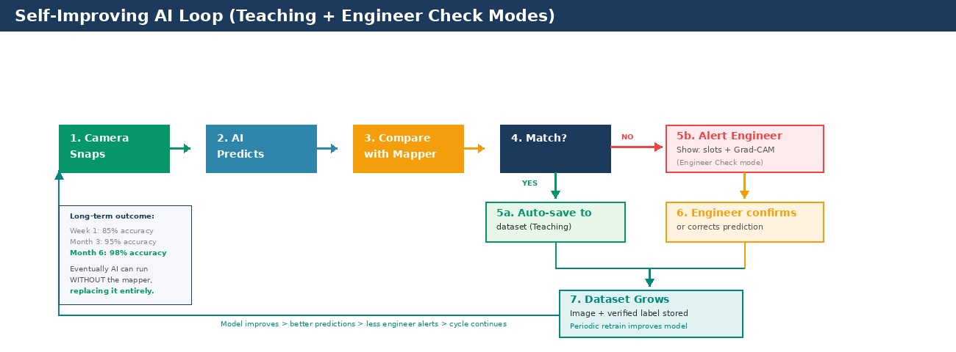
Figure 7: How the AI Improves Over Time
Teaching Mode and Engineer Check Mode together create a continuous improvement cycle. The mapper finishes, which triggers the camera. The AI predicts all 25 slots in under a second. The system compares with the mapper result: matches get auto-saved, mismatches alert an engineer with Grad-CAM. Either way, the dataset grows. The model retrains on this growing dataset, accuracy improves, fewer alerts appear, and the cycle continues. The long-term goal is that the AI replaces the mapper entirely.

3.4 Dynamic Robot and Cassette Support
The application supports both robot types (UV Series and 2000 Series) and both cassette sizes (6-inch and 8-inch) from a single interface. In Levels 1 and 2, the user manually selects these from the sidebar. In Level 3, the AI auto-detects from the camera image. For dark room environments, the architecture supports different camera types (visible light, infrared, thermal). The camera input is abstracted so any camera type feeds the same AI pipeline.

3.5 Functional Requirements
ID | Requirement | Priority
F01 | Classify 25 slots per cassette in under 1 second | Must have
F02 | Support both UV Series and 2000 Series robots | Must have
F03 | Support both 6-inch and 8-inch cassettes dynamically | Must have
F04 | Provide Grad-CAM explanation for every prediction | Must have
F05 | Side-by-side AI vs Mapper comparison per slot | Must have
F06 | Four operating modes: Live, Teaching, Engineer Check, Standby | Must have
F07 | Teaching Mode: auto-save matched predictions to dataset | Must have
F08 | Engineer Check: notify on mismatch, allow confirm/correct | Must have
F09 | Camera selector for multiple cameras | Should have
F10 | Robot type and cassette size auto-detection from image | Could have
F11 | API endpoint (POST /api/inspect) for Trymax software | Should have
F12 | Web dashboard for read-only monitoring | Should have
F13 | Periodic model retraining from growing dataset | Could have
F14 | Support IR/thermal cameras for dark room environments | Could have

3.6 Technical Requirements
ID | Requirement | Priority
T01 | Per-slot classification accuracy > 90% | Must have
T02 | Inference time < 1 second for 25 slots | Must have
T03 | False positive rate < 2% | Must have
T04 | Background robustness: < 5% accuracy drop | Must have
T05 | AI vs Mapper agreement > 95% | Must have
T06 | Python + PyTorch + FastAPI stack | Must have
T07 | Git version control for code handover | Must have

3.7 Build Order: What Comes First?
One of the first things I had to figure out is the right order to build everything. You cannot build an application around an AI model that does not exist yet, and you cannot train an AI model without data. So the order is:
Step 1: Data first (Weeks 1-6). I need photos of cassettes before I can do anything else. I start by photographing cassettes at Trymax using my iPhone, organizing them in the folder structure I designed, and building augmentation scripts. Without data, there is no AI.
Step 2: AI model (Weeks 7-14). Once I have enough images, I train the CNN. I compare architectures (MobileNet, EfficientNet), add Grad-CAM, and validate with engineers. This model becomes the core that everything else wraps around.
Step 3: Application (Weeks 15-18). Now I build the frontend and connect everything. The FastAPI backend wraps the model. I add camera mode controls, the mapper event trigger, and the Teaching/Engineer Check workflows.
Step 4: Network + Handover (Weeks 18-20). I move the dataset to the company network, test the PHP integration, and document everything for Level 3 continuation.
This order makes sense because each step depends on the previous one. Data first, model second, application third.

4. Technical Approach

4.1 AI Model Pipeline
The AI works in three stages. I chose this approach because separating the stages makes each part easier to debug and improve independently:
Stage 1 - Cassette Detection (ROI): Locate and crop the cassette from the full camera image. This eliminates background noise (people walking by). For the prototype with a fixed camera, I can use a fixed crop. For production, a lightweight detector or edge-detection approach.
Stage 2 - Slot Classification (CNN): Segment the cropped cassette into 25 slot regions based on known geometry. Classify each slot using a CNN with transfer learning. Starting from a pretrained model like MobileNet means good results with a few hundred images.
Stage 3 - Grad-CAM Generation: For every prediction, generate a heatmap showing which image regions the model focused on. Available via the /explain endpoint.

4.2 Data Strategy
Phase 1 - Prototype Dataset (iPhone): I am collecting photos at Trymax myself, from various distances and angles. Folder names encode the 25-slot configuration. I have 30 predefined configurations covering common scenarios, single faults, and multi-fault combinations.
Phase 2 - Augmented Dataset: I will expand using augmentation: rotation, brightness/contrast, noise, background replacement. Target: 1,000+ augmented samples per class.
Phase 3 - Production Dataset (Level 3): Every production scan gets saved with AI prediction and mapper ground truth. The model retrains periodically. After six months: thousands of real-world labeled images.

4.3 Explainable AI (XAI) Strategy
Explainability is a core deliverable, not an afterthought. I see Grad-CAM serving three purposes:
Trust Building: Engineers see the AI focuses on wafer edges and slot regions, not background. Combined with mapper comparison, this builds real confidence.
Debugging: If the model makes errors, Grad-CAM reveals whether the issue is attention (wrong features) or data quality. This saves development time.
EU AI Act Compliance: The 2024 AI Act mandates transparency for high-risk AI. Building explainability from day one ensures future compliance readiness.

4.4 Technology Stack
Component | Technology | Level | Purpose
ML Framework | Python + PyTorch | All | Training, inference, Grad-CAM
Vision | OpenCV | All | Preprocessing, ROI, augmentation
CNN | MobileNet/EfficientNet | All | Transfer learning (fast inference)
XAI | Grad-CAM | All | Visual heatmap explanations
ML API | FastAPI | All | /predict and /explain endpoints
Backend | PHP | Level 2+ | Image routing, storage, API layer
Frontend | HTML/CSS/JS | All | Live dashboard
Database | MySQL/SQLite | Level 2+ | Prediction history, image storage
Auto-pipeline | Python scripts | Level 3 | Auto-store, retrain trigger
Version Control | Git | All | Code handover

5. Planning (20 Weeks)

5.1 Phase Overview
I divided the internship into six phases. The first four phases (weeks 1 through 14) are identical for all delivery levels. The difference only shows up in Phase 5, where the integration scope varies.
Phase | Weeks | Focus | Deliverable | Level
1 | 1-3 | Onboarding, data collection, 25-slot dataset v1 | Labeled dataset | All
2 | 4-6 | Data pipeline, augmentation, ROI detection, slot segmentation | Data pipeline | All
3 | 7-10 | Baseline CNN, per-slot evaluation, architecture comparison, first Grad-CAM | Working model | All
4 | 11-14 | Speed optimization (<1s), robustness, full XAI analysis, mapper comparison | Optimized model | All
5 | 15-17 | Frontend dashboard + live camera (L1). PHP + API (L2). Camera setup (L3). | Prototype | L1/L2/L3
6 | 18-20 | Testing, documentation, presentation, code handover. Auto-pipeline (L3). | Final report | All

5.2 Detailed Weekly Breakdown
Week 1: Onboarding. Facility tour. Meet software team, SIEE, process engineers. Understand NEO machines (UV + 2000 series), mapper, SVCLog, sensors. IT setup.
Week 2: iPhone photography sessions. Folder naming convention (25-slot). Document distances, angles, lighting. Create intentional fault configurations.
Week 3: Complete dataset v1. Verify labels with engineers. Assess class distribution. Identify gaps.
Week 4-5: Data pipeline: folder reader, image resizing (224x224), train/val/test split (80/10/10), augmentation pipeline.
Week 6: ROI detection (cassette crop). Slot segmentation based on cassette geometry. First transfer learning experiments.
Week 7-8: Baseline MobileNet model. Per-slot accuracy evaluation. Confusion matrix analysis.
Week 9-10: Architecture comparison (MobileNet vs EfficientNet). First Grad-CAM implementation. Present results to team.
Week 11-12: Background robustness training. Speed optimization (model pruning, quantization if needed) to hit <1s target.
Week 13-14: Full Grad-CAM analysis across all slot states. Engineer validation sessions. Side-by-side mapper comparison. XAI report.
Week 15-16: Frontend dashboard with live camera. FastAPI endpoints. PHP backend + API documentation (Level 2). Camera installation (Level 3).
Week 17: End-to-end integration. Connect all components. Testing.
Week 18-19: Comprehensive testing. Documentation. Installation guide. Final report. Auto-pipeline for dataset growth (Level 3).
Week 20: Presentation to Trymax. Code handover (Git). Knowledge transfer sessions.

6. Success Criteria
These are the measurable targets I am working toward. My internship coordinator and I agreed on these together:
Criterion | Target | Priority | Measured By | Level
Per-slot accuracy | > 90% | Critical | Test set | All
Inference (25 slots) | < 1 second | Critical | Benchmark | All
False positive rate | < 2% | Critical | Test set | All
Background robustness | < 5% accuracy drop | High | Varied set | All
Grad-CAM validation | Focus on wafer region | High | Expert review | All
AI vs Mapper agreement | > 95% | High | Side-by-side | All
6-inch + 8-inch support | Both cassette types | Medium | Testing | All
API returns valid JSON | SlotOccupationState[] | High | API test | L2+
Auto-dataset storage | Every scan saved | Medium | Log audit | L3

7. Risks and Mitigation
I identified the following risks early on and have a mitigation plan for each:
Risk | Chance | Impact | Mitigation
Insufficient training data | Medium | High | Transfer learning + augmentation. 200 real images can be enough with pretrained models.
Class imbalance (few faults) | High | Medium | Intentionally create fault configs. Class weights. Heavy minority augmentation.
Background variation | Medium | High | Two-stage: ROI detection removes background before classification.
iPhone != production camera | Medium | Medium | Acknowledged as prototype. Retrain when production cameras installed.
<1 second target missed | Low | Medium | MobileNet: 50-200ms typical. Pruning/quantization fallback.
Camera delivery delay (L3) | Medium | High | Order early. Start with Level 1/2 and upgrade when hardware arrives.
20 weeks too short for L3 | Medium | Medium | MVP-first: deliver Level 1/2. Extend to Level 3 if time permits. Coordinator is aware.
Multiple cassette types | Medium | Medium | Start with one type. Add cassette_type parameter for future expansion.

8. Communication and Supervision
Meeting | Frequency | Participants | Purpose
Team stand-up | Daily | Software team | Progress updates, blockers
Supervisor meeting | Weekly | Company supervisor | Technical direction, feedback
School check-in | Bi-weekly | School supervisor | Academic progress
Sprint demo | Every 2-3 weeks | Team + stakeholders | Demonstrate results

I plan to work hybrid: 2 to 3 days on-site (for collaboration, machine access, and photography) and 2 to 3 days remote (for focused development work). All code is managed via Git, and I keep a daily logbook to track my progress.

9. Deliverables
Deliverable | Week | Level | Description
Plan van Aanpak | 2 | All | This document
Project Proposal | 2 | All | Problem definition, analytic approach, data requirements
Dataset v1 (25-slot) | 3 | All | iPhone photos in SlotOccupationState folder structure
Data Pipeline | 6 | All | Loading, augmentation, ROI detection, splitting scripts
Baseline Model + Evaluation | 10 | All | Working CNN with per-slot metrics and confusion matrix
XAI Report | 14 | All | Grad-CAM analysis, engineer validation, mapper comparison
Frontend Dashboard | 17 | L1+ | Live camera + predictions + Grad-CAM + mapper comparison
API + PHP Backend | 17 | L2+ | POST /api/inspect endpoint, documentation
Production Pipeline | 19 | L3 | Camera integration, auto-storage, retrain scripts
Final Report + Handover | 20 | All | Report, Git repository, presentation, knowledge transfer

10. Glossary
Term | Definition
Cassette / Tray | 25-slot holder for transporting wafers (6-inch or 8-inch)
Mapper | Mechanical sensor on robot arm, inspects slots sequentially in 30-45 seconds
SlotOccupationState | Industry enum: Undefined(0), Empty(1), NotEmpty(2), CorrectlyOccupied(3), DoubleSlotted(4), CrossSlotted(5), Reserved(6)
CNN | Convolutional Neural Network for image classification
Transfer Learning | Reusing pretrained model (MobileNet/EfficientNet) on new task with limited data
Grad-CAM | Visual heatmap showing which image regions the AI focuses on for its prediction
ROI | Region of Interest: cassette area cropped from full camera image
FastAPI | Python web framework for /predict and /explain API endpoints
SVCLog | Trymax internal logging format used by machines and the mapper
NEO Software | Trymax's existing machine control application for the NEO series
Load Port | Interface where cassettes are loaded into the machine for processing
IPC | Industrial PC: Windows computer inside each machine running software and storing logs

